**Gebze Technical University**

**Computer Engineering Departman**

**CSE 436 Digital Integrated Circuit**

**Homework #2**

**Berkan AKIN**

**171044073**

**Note: 1 bit adder works without errors. Full adder makes a total of mistakes.**

**1 Bit Adder Truth Table**

+---+---+-----+-----+------+

| A | B | Cin | Sum | Cout |

+---+---+-----+-----+------+

| 0 | 0 | 0 | 0 | 0 |

+---+---+-----+-----+------+

| 0 | 0 | 1 | 1 | 0 |

+---+---+-----+-----+------+

| 0 | 1 | 0 | 1 | 0 |

+---+---+-----+-----+------+

| 0 | 1 | 1 | 0 | 1 |

+---+---+-----+-----+------+

| 1 | 0 | 0 | 1 | 0 |

+---+---+-----+-----+------+

| 1 | 0 | 1 | 0 | 1 |

+---+---+-----+-----+------+

| 1 | 1 | 0 | 0 | 1 |

+---+---+-----+-----+------+

| 1 | 1 | 1 | 1 | 1 |

+---+---+-----+-----+------+

**Transistor Desing**

*Sum*=*ABCin*​+*ABCin*​+*ABCin*​​+*ABCin*​​

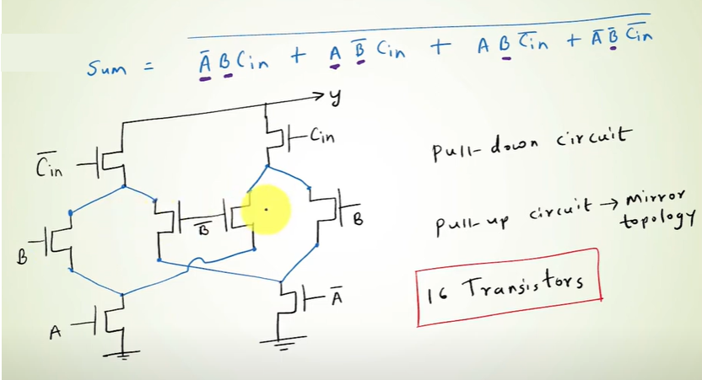

*Cout*=*AB*+*BCin*​+*ACin*​

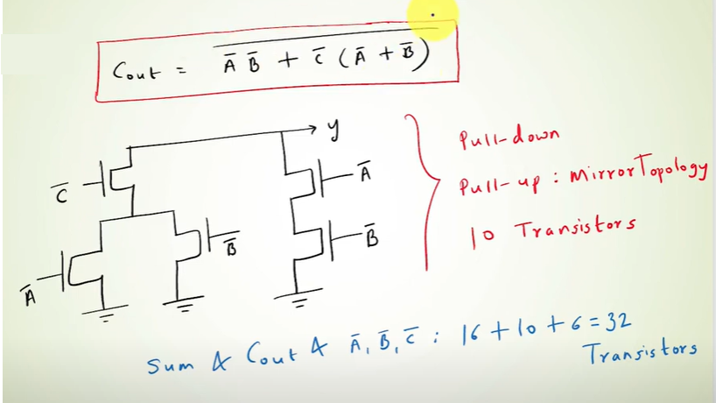

**Transistors Diagram(Pull Down Network)**

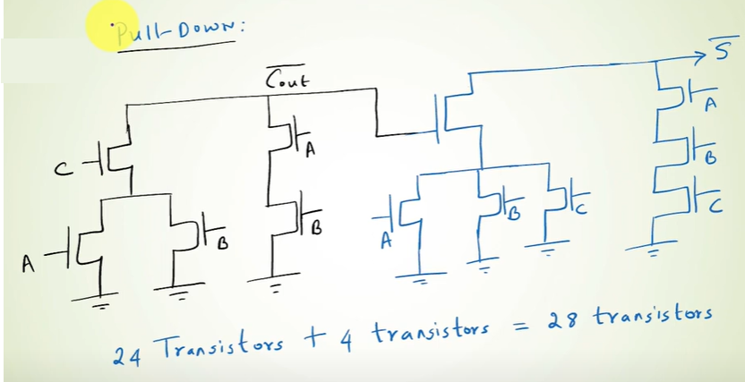

**Stick Diagram**

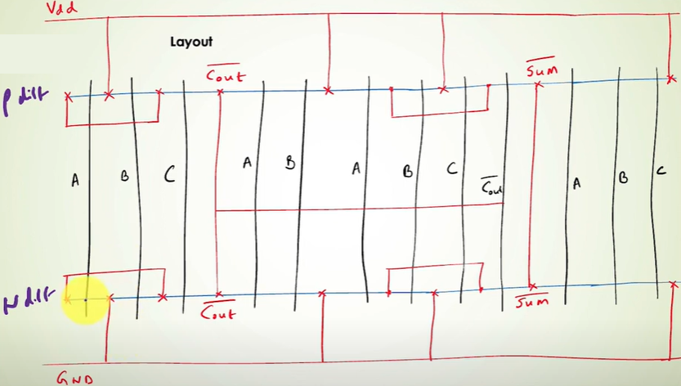

**Magic Desing**

1. **Bit Full Adder**

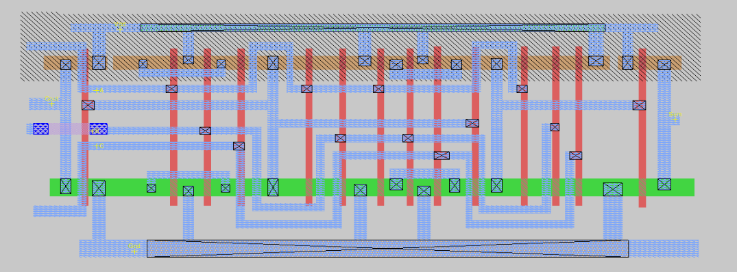

**4 Bit Full Adder**

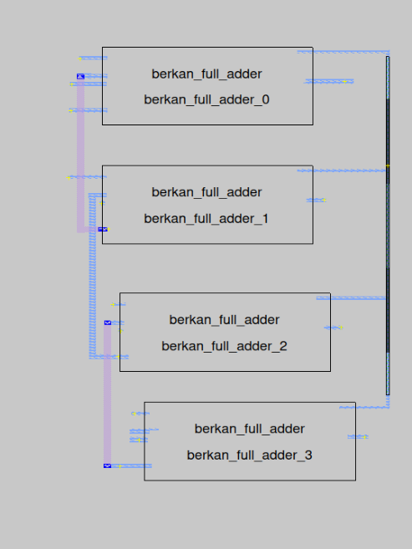

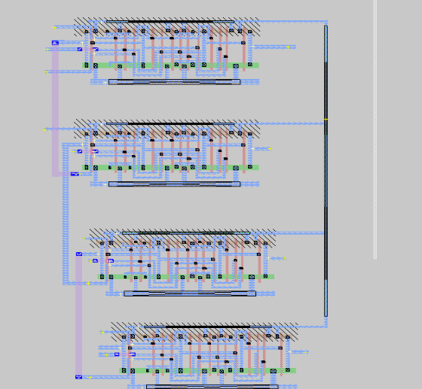

**Test Case**

**1 Bit Full Adder**

**A B C | Sum Cout**

**0 0 0 | 0 0**

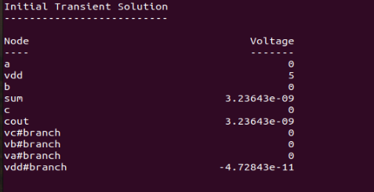 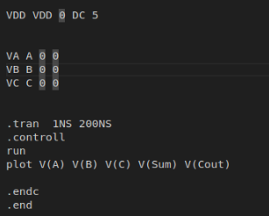

**A B C | Sum Cout**

**1 0 0 | 1 0**

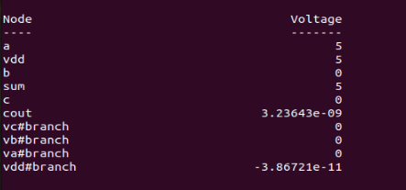 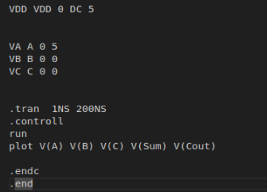

**A B C | Sum Cout**

**1 1 0 | 0 1**

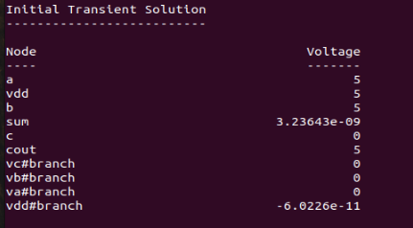 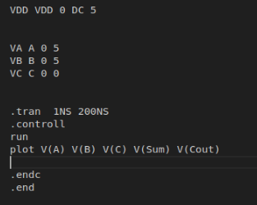

**A B C | Sum Cout**

**1 1 1 | 1 1**

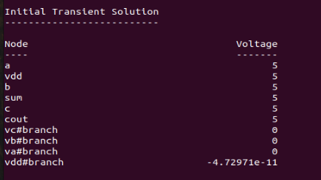 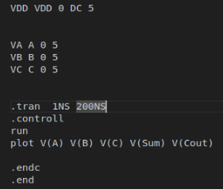

**4 Bit Full Adder**

**A4 A3 A2 A1 + B4 B3 B2 B1 = Sum4 Sum3 Sum2 Sum1**

**0000 + 0000 = 0000**

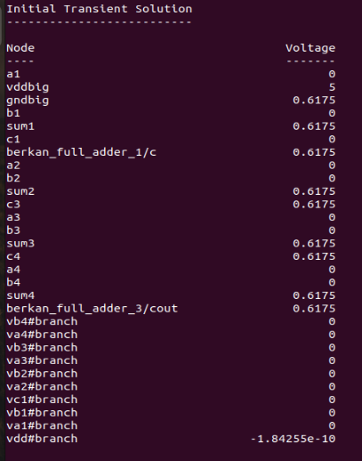 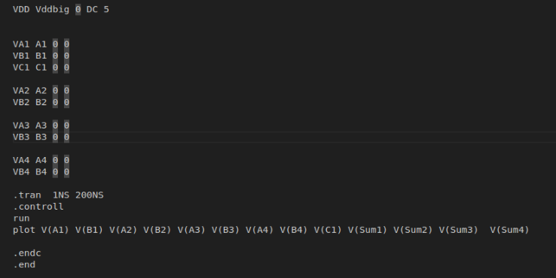

**A4 A3 A2 A1 + B4 B3 B2 B1 = Sum4 Sum3 Sum2 Sum1**

**0001 + 0000 = 0001**

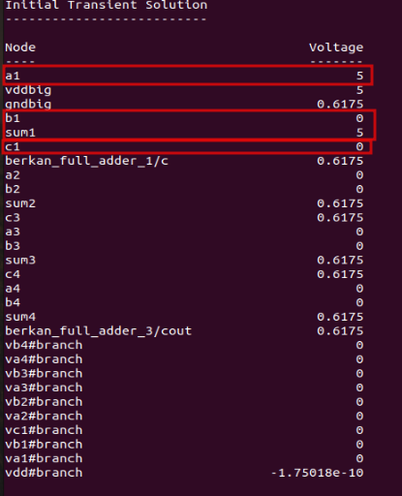

**A4 A3 A2 A1 + B4 B3 B2 B1 = Sum4 Sum3 Sum2 Sum1**

**0011 + 0000 = 0011**

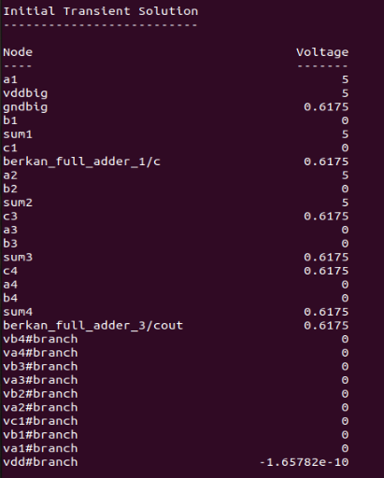

**A4 A3 A2 A1 + B4 B3 B2 B1 = Sum4 Sum3 Sum2 Sum1**

**0011 + 0011 = 0110**

**! It produces wrong results**

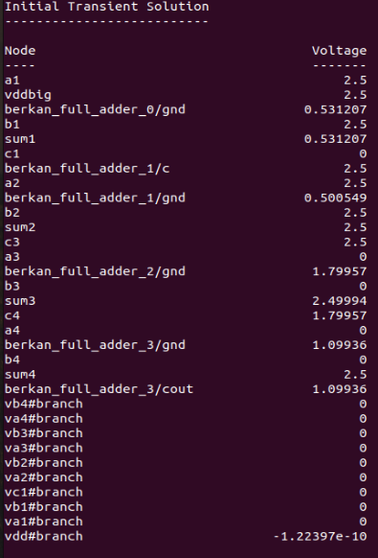

**Meaningless Plot Occurred**

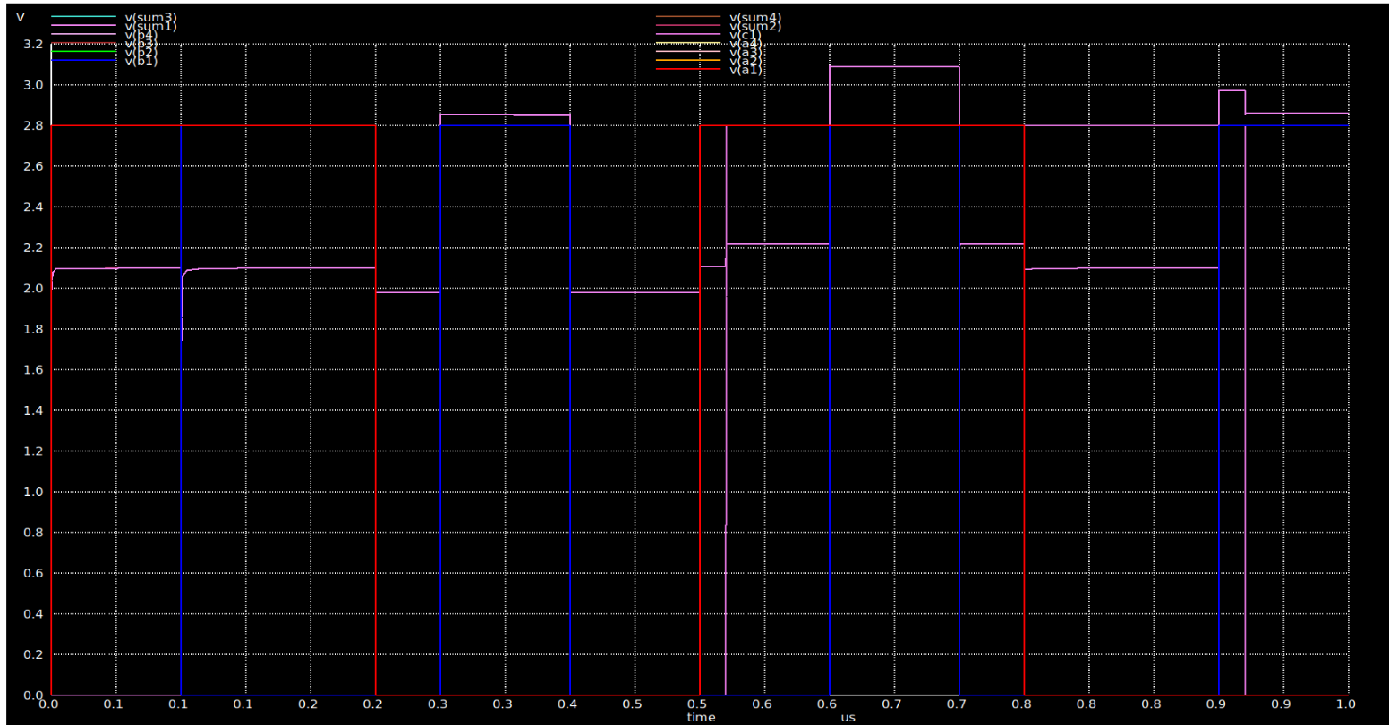

**Resources**

**https://www.youtube.com/watch?v=N3H-QsGNIiI&t=1317s**